2.1 Experiment No: 02

2.2 Experiment Name:

* 1. Take two signals and show the convolution using tabular method in MATLAB.
  2. Take two signals and show the convolution using circular method in MATLAB.

2.3 Theory: Convolution is a mathematical operation used to express the relation between input and output of an LTI system. It relates input, output and impulse response of an LTI system as **y(t)=x(t)∗h(t).** Where y (t) = output of LTI

x (t) = input of LTI

h (t) = impulse response of LTI

There are two types of convolutions:

* Continuous convolution
* Discrete convolution

Convolution is a formal mathematical operation, just as multiplication, addition, and integration. Addition takes two numbers and produces a third number, while convolution takes two signals and produces a third signal. Convolution is used in the mathematics of many fields, such as probability and statistics. In linear systems, convolution is used to describe the relationship between three signals of interest: the input signal, the impulse response, and the output signal.

**2.4 Code for convolution using tabular method:**

clc

clear all

x=[1 2 3 4]

h=[4 4 3 2]

a=length(x);

b=length(h);

n=a+b-1;

y=zeros(1,n);

l=1:n;

for i=0:n

for j=0:n

if((i-j+1)>0 && (i-j+1)<=b && (j+1)<=a)

y(i+1)=y(i+1)+x(j+1).*h(i-j+1);

end

end

end

disp(y)

subplot(3,1,1)

stem(x)

xlabel('n');

ylabel('x[n]');

subplot(3,1,2)

stem(h)

xlabel('n');

ylabel('h[n]');

subplot(3,1,3);

stem(l,y)

xlabel('n');

ylabel('y[n]');

Output:

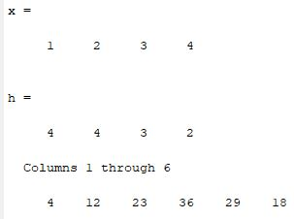

Figure 2.1: Convolution of two discrete signals using tabular method

Output Signal:



Figure 2.2: Showing two input signals with the output signal

2.5 Code for convolution using circular method:

clc

clear all

close all

z=[];

x=input('Enter the array:');

l1=length(x);

h=input('Enter the second array:');

l2=length(h);

if(l1>l2)

c=l1-l2;

for i=1:c

h=[h 0];

end

else

(l2>l1)

c=l2-l1;

for i=1:c

x=[x 0];

end

end

z=[z h'];

a=h;

for i=1:length(h)-1

a=ci(a);

z=[z a'];

end

y=z*x';

disp(y');

subplot(3,1,1)

stem(x)

xlabel('n');

ylabel('x[n]');

subplot(3,1,2)

stem(h)

xlabel('n');

ylabel('h[n]');

subplot(3,1,3);

stem(y)

xlabel('n');

ylabel('y[n]');

ci.m

function a=ci(m)

x1=m;

a=[];

c=length(x1);

a=[a x1(c)];

for i=1:length(x1)-1

a=[a x1(i)];

end

end

Output:

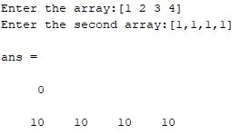

Figure 2.3: Convolution of two discrete method using circular method

Output:



Figure 2.4: Showing two input signals with the output signal